

|  |  |  |
| --- | --- | --- |
| **QUANTITATIVE SCIENCES DEPARTMENT** | |  |
| **Course:** A1MAA | |
| **Topic Title**: Investigation 3 – Pythagoras Theroem  **Part 1** –  **Preparation activity** | |
| Student Name:_____________________________________ | Due Date: _______2015 | | |
| Special Instructions: Work must be completed neatly on separate paper,  showing all working out, including diagrams and answers. |  | | |
|  |  | | |

**Question 1**

From a tree Jenni walked 6 m North then 4 m East before turning North and walking a further 5 m. From there she walked due West for 10 m to arrive at the play area. Helen walked from the same tree directly to the play area.

(a) Using a scale of 1 cm = 2 m, draw an accurate diagram to represent these walks.

(b) Using the diagram drawn in (a), determine the distance (to 1 decimal place) that Helen walked.

(c) Use Pythagoras’ theorem to determine the distance (to 1 decimal place) that Helen walked.

(d) For the calculations from (b) and (c);

(i) which one represents the most accurate calculation of the distance that Helen walked? Justify your conclusion.

(ii) what is the difference between them?

(ii) determine the difference as a percentage of the calculation from (c).

Round this percentage to the nearest whole number.

**Question 2**

Children’s toy kites are sometimes made in the shape of a mathematical kite with pieces of dowel placed at right angles to form a frame, and string used to connect the ends of the dowel so that the string lies along the perimeter of the kite.

The diagram provided shows the measurements (in cm) of the dowel for one of these kites.

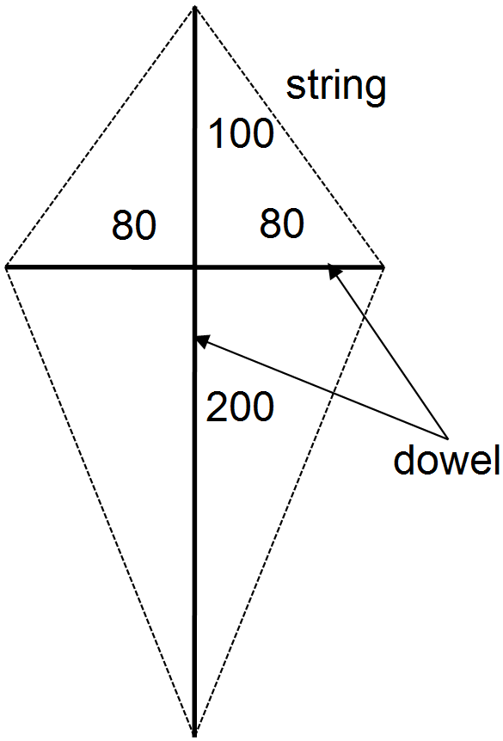

(a) Calculate the length of string needed to

form this perimeter.

(b) If an extra 10 cm is needed at each corner,

what is the total length of string now required?

(c) How many metres of string will be needed

for 100 kites?

(d) Using the measurements provided on the diagram,

calculate the area of the kite.

**Question 3**

Luke sells juice containers in two different shapes and he wants to know how long the drinking straws

should be.

He wants them to protrude 10 cm from the edge of the juice container in each shape (see diagrams).

Showing use of Pythagoras’ theorem, determine the length (to the nearest cm) of the straws required by Luke.

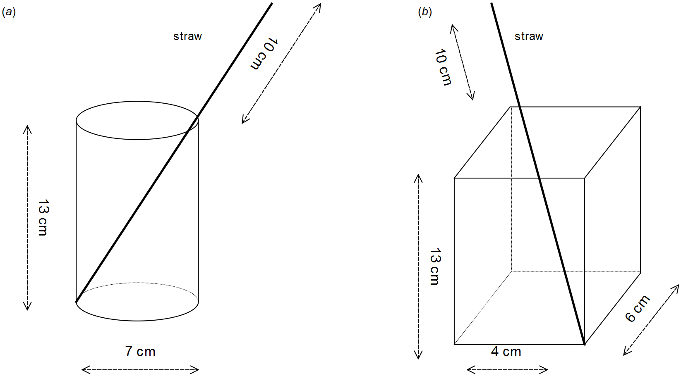

**Question 4**

As pictured in the diagram below, six wooden stakes are placed around a small tree to provide a frame

for netting to protect the tree from birds. The stakes are all 3 m long and they meet 1.8 m above

the ground, directly above the tree.

On the ground, the ends of the stakes are equidistant from each other and they are also

equidistant from the tree.

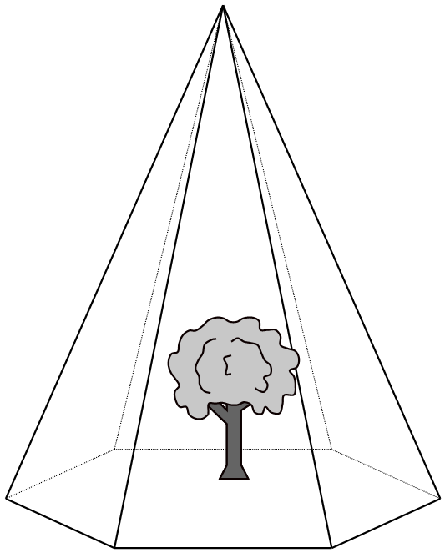

(a) How far from the tree should the stakes be placed?

(b) Calculate the distance at ground level between two adjacent stakes.

Show how you determined this distance.

(c) Calculate the area of netting required.

Justify any use of Pythagoras’ theorem.

**Question 5**

The diagram provided represents the part of a soccer field near the goals and it shows the rectangular goal and penalty areas. Position A is 5.5 m from the northern edge of the outer rectangle and opposite the middle of the goal mouth. Position B is 5.5 m from the southern edge and 11 m from the eastern edge of the outer rectangle.

Positions C and G are located at the vertices of rectangles

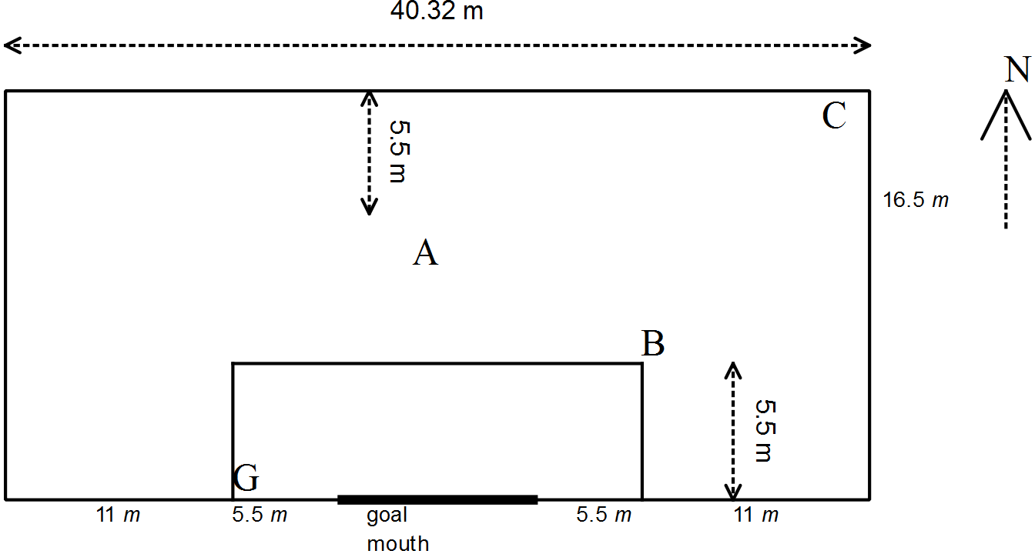

(a) Determine the length of the goal mouth.

(b) To reach the goal mouth from position A, how long is the shortest kick possible?

(c) Calculate the length of straight kicks to position G

(i) from position A

(ii) from position C

(iii) from position C after hitting a player at position B.

**Question 6**

A piece of furniture foam is in the shape of a triangular prism and all sides of the triangle are equal in length. Let *s* represent the length of each side of the triangle.

(a) Draw a labelled diagram to represent the triangle.

(b) A line drawn from a vertex of the triangle to the midpoint of the opposite sign makes a right angle at the midpoint. Draw this on the triangle from part (a).

(c) Write an expression to calculate the length of the line drawn in part (b).

(d) Show use of substitution in your expression in part (c) to calculate the height of a piece of foam in the shape of a triangular prism when all the lengths of the sides of the triangle are 20 cm.